Assignment: Day-6 Network Devices

1. Functions and Typical Ports
Device | Main Function | Typical Ports
Switch | Connects devices within a LAN | Ethernet (RJ-45), Console
Router | Routes traffic between networks | WAN, LAN Ethernet, Console
Hub | Broadcasts data to all connected devices | Ethernet (RJ-45)
Firewall | Filters and secures network traffic | WAN, LAN, Management
Access Point | Provides wireless Wi-Fi access | Ethernet, Power, Antennas

2. Labeled Network Devices
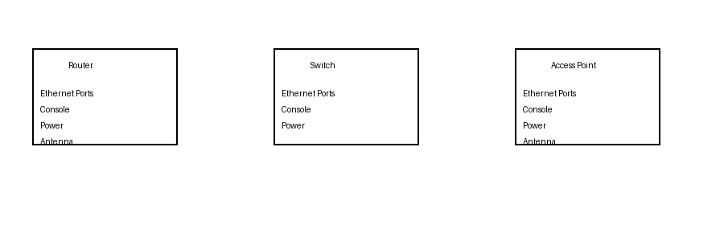

3. Role of Network Devices (Instagram)
When I open Instagram, my phone first connects to a Wi-Fi access point, which provides wireless connectivity. The router forwards the data packets to the internet and performs NAT so the request reaches Instagram's servers. A firewall protects the network by filtering unwanted traffic.

4. College Wi-Fi Issue
A possible reason for slow or unstable Wi-Fi is that the access point is overloaded with too many connected users or has poor coverage. Upgrading to a Wi-Fi 6 access point with higher device capacity and better traffic management can improve speed, stability, and overall user experience.

